10 Spooky Curses that were Debunked with really Simple Science
By Evan Hoovler
Curses are like great action movies: They are really gripping stories, as long as you ignore the glaringly unbelievable plot holes. To illustrate this, we took a look at 10 well-known curses that were debunked with really basic scientific observations.

Curse of the "H." House

Soon after occupying an old, allegedly paranormal house, a family began to feel creeped out. These feelings progressed to hearing bells, footsteps, seeing ghosts, feeling paranoia, and being assaulted in their sleep. It turns out an old furnace had been leaking carbon monoxide, slowly poisoning the family and driving them to the brink of insanity. Once the furnace was fixed, the family no longer had violent hallucinations, nor were they ever again driven mad by supernaturally inflated heating bills.

“The Cursed Crying Boy Painting”
“The Crying Boy” is a mass-produced painting by Italian artist Bruno Amadio. Firemen began reporting finding copies of a painting of a weeping child in burnt-out sites, totally unharmed. An investigation revealed that the varnish used to make these painting copies was fire-resistant. Science is now hard at work making children’s pajamas coated in this varnish.

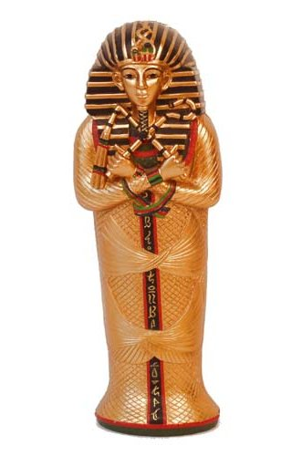

“The Curse of the Pharaohs”

As the legend goes, people who open Egyptian tombs frequently get sick and die as a result of the “Pharaoh’s Curse.” Turns out that Pharaoh’s tombs have been found to contain danger in the form of fungus spores, ammonia fumes, bacteria, formaldehyde, hydrogen sulfide, and even radioactive uranium as a result of the mummification and preservation processes.

“The Cursed Coventry Cellar”

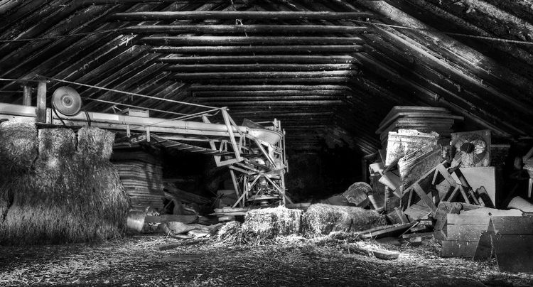
The 14th Century Cellar is adjacent to Coventry University beneath the Tourist Information Centre, which is built on the site of a 14th century house. The house was originally owned by the Benedictine Priory that stood opposite, where Coventry Cathedral now stands. At the time the cellar was built, Coventry was a center for the wool and cloth trade and it would most likely have been used to store. Niches in the walls would have contained valuable goods such as spices and would have had lockable doors attached. The cellar is built of local red sandstone and is of such quality that it has survived many new houses being built above it. The final house was destroyed, along with the Cathedral, during the Coventry Blitz of 1940. This blocked the cellar's remaining entrance and its presence was forgotten for a time. Rediscovered during the excavation for the foundations of the Tourist Information Centre, the cellar now serves this new building. Accessed by well-lit modern steps and underground passageway it is open to the public and has a steady flow of visitors. A number of stories began to emerge form several witnesses, with many reporting that they felt dread and fear, saw ghostly apparitions, and heard weird noises. Investigators found that infrasound from nearby pipes was causing the effects, even vibrating people’s eyeballs to cause visual hallucinations. Vic Tandy, a paranormal investigator, explored the site and wrote a famous paper debunking the site once and for all. The “ghosts” easily disappeared if one only closed their eyes and held their fingers over them for a moment to steady them.

“The Curse of the Infant Haunting”

Many spooky stories include the death of an infant or a child, and in the late 1800s when such deaths were more common, there were many reported “hauntings” by these infants. Entire families moved, and townsfolk refused to go near such buildings or would burn them to the ground. That changed when Dr. Todd Brown investigated and found that many other culprits were to blame: loose tiles in chimneys would make a whistling or crying noise, rats running around at night sounded like childhood footsteps, and “cold spots” were due to poor construction or lack of insulation.

“The Curse of the Ghost Thief”

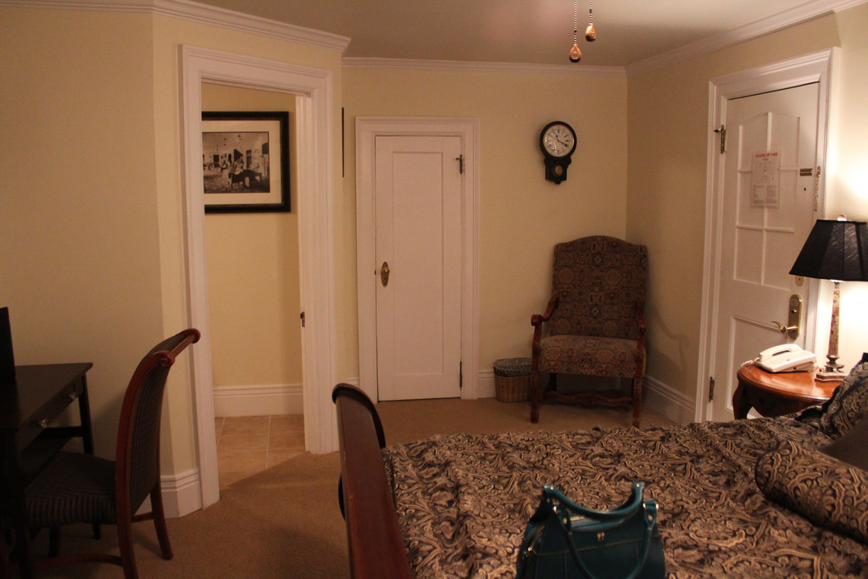
In the Stanley Hotel room 401, guests reported their possessions being stolen or moved due to the curse of a thief who had died in that room. This went on for many years until investigators found that the room was built too close to the elevator—the constant vibrations from the elevator were causing small objects to vibrate and move out of sight, usually behind large furniture where they were not easily seen.

“James Dean’s Spyder Curse”
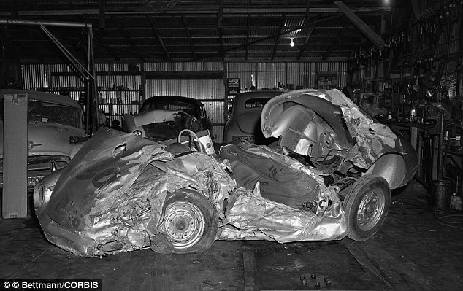
After famous actor James Dean was killed in a crash in his Porsche 550 Spyder in 1955, many parts of this racecar were taken and used in other cars with disastrous results. The transmission that was used in another was soon involved in a fatal crash. The person who got the engine was also killed in a fatal car racing crash. Someone bought two of the tires and almost immediately there was an accident where both tires blew out (though the driver thankfully lived). Rumors of cursed car parts began flying around, but common sense more than science can solve this “curse”: if you take used parts from a wrecked car, they are more likely to malfunction. Considering that James Dean was on his way to a race and was driving the car to the race because the transmission and engine weren’t properly broken in yet, it makes even more sense that these parts would fail.

“Mary King’s Close Curse”

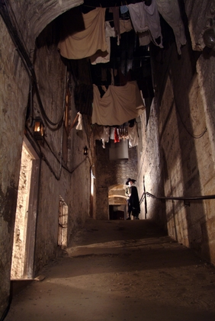
Mary King's Close is an old Edinburgh close (or alleyway) under buildings in the Old Town area of Edinburgh, Scotland. It took its name from one Mary King, daughter of advocate Alexander King, who in the 17th century had owned several properties within the close. The close was partially demolished and buried under the Royal Exchange, and later being closed to the public for many years, the complex became shrouded in myths and urban legends; tales of ghosts and murders, and myths of plague victims being walled up and left to die abounded.
The close has had a reputation for hauntings since at least the 17th century. Cold spots, weird lights, and odd apparitions were said to be the curse of plague victims stored in this historic landmark. It has been pointed out that this particular close ran the nearest of any to the old Nor Loch, a stagnant and highly polluted marsh; biogas escaping into the close and creating eerie lights may have been the cause for these rumors of spirit hauntings. The noxious gasses from the nearby swamp were messing with the humidity and causing odd light reflections and hallucinations. The levels of contaminants in the swamp were so high that breathing in the fumes could cause massive group hallucinations.

“The Spinning Cursed Statue”
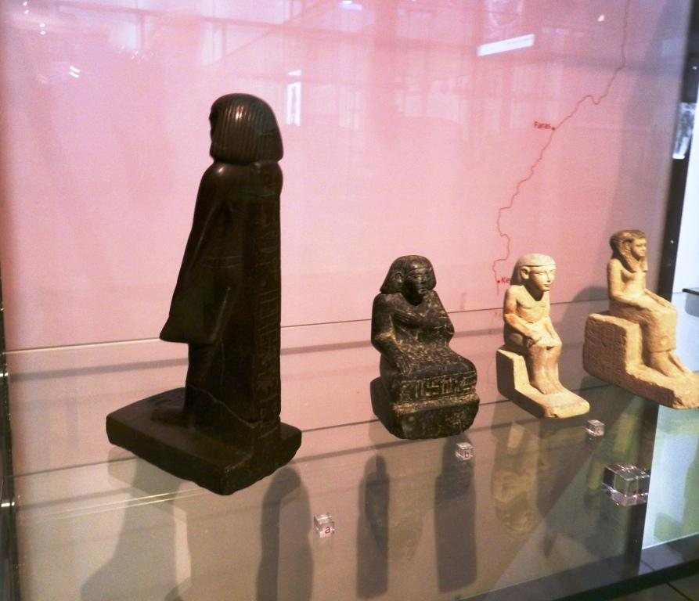
At a Manchester museum, a supposedly cursed statue of a mummy kept rotating mysteriously. Museum patrons were both fascinated and terrified of the mummy statue, and many called for the statue to be returned to Egypt to avoid a pharaoh’s curse. Video surveillance showed the statue moving on it’s own night after night, always at the same time. Scientists found that the statue’s unusually convex (rounded) base, combined with vibrations from a nearby subway station, was causing the movements. Moving the statue to a vibration-proof box soon fixed the issue of the spinning statue.

“Cursed Terra Cotta Warrior Army”
On March 29, 1974, farmers in the Xi’an Shaanxi province digging a well unearthed what appeared to be an army of terra cotta warriors. They had accidentally discovered the burial site of Qin Shi Huang, the First Emperor of China, and his “army” of terra cotta warriors he had built to protect him in the afterlife. The 7 farmers who discovered the Terra Cotta Army in China were soon plagued with illness, famine, and even suicide. Those who attempted to excavate the army soon befell the same fate. Sounds like the Emperor’s curse, eh? Instead, scientists discovered that the well they had been digging had a dangerous level of mercury in the soil that had risen to the air when the digging started. Side effects of mercury exposure include: tremors, emotional changes (such as mood swings, irritability, nervousness, excessive shyness), insomnia, neuromuscular changes (such as weakness, muscle atrophy, twitching), headaches, and feelings of (such as “pins and needles” or “being watched”) and other symptoms.
