Resume Writing Article #1
While it’s not as exciting as learning to drive, creating your first resume is a vital step in launching your career. The process may seem daunting. You have to put all of your best qualities on paper, make yourself look more attractive than the next person and completely sell yourself, all on one sheet of paper. “You have only a few seconds to snag the employer’s attention,” writes Seattle-based career coach Robin Ryan in Winning Resumes, (John Wiley & Sons, Inc., 2003). “You must sell the employer within 15 seconds of looking at your resume, or you’ll lose the job.” Here are seven tips to help you catch an employer’s attention.
1. Start with the basics.
It sounds obvious, but your resume must include your name, address, phone number and e-mail address. Be mindful of the address you include. Use a permanent address, such as your parent’s address. Take care with your e-mail address too. “Make your user ID related to your name, not any nickname attributions,” Ryan says. If you want to appear professional to an employer, a user ID like “sexylegs2000” will not work.
2. Include a resume objective and summary.
These sections come right after your personal information and, for a first-time job seeker, should be short and to the point.
- For example: Seeking a position at XYZ Company where I can maximize my 10+ years of management, quality assurance, program development, and training experience.
Your “summary of skills” should highlight experiences and qualifications that the employer is seeking. Remember, Ryan says, “a resume is not about what you want. It’s about what you offer an employer.”
3. Choose the right resume style.
There are three basic types of resumes: chronological, functional and combination. Chronological resumes focus on work experience, and list professional experience in order from most to least recent. Functional resumes concentrate more on skills. A combination style works well for first-time job seekers. You can point out professional experience, but also draw more attention to your skills, since your work experience is probably limited. Ryan suggests that first-time resume writers divide their resume into these categories: work experience, academic experience and community service/extracurricular experience.
4. Brainstorm your experience and skills.
While you may be struggling to think of relevant work experience, Ryan says that you have more than you realize. For example, if you have worked in a retail operation, your skills and qualifications include customer service skills, dependability, accountability, the ability to work as a part of a team and experience in managing money. Were you a full-time summer babysitter? This means you coordinated schedules, handled finances, and were extremely responsible. Many skills learned in part-time positions are quite relevant to the corporate world. Don’t underestimate the skills you have gained.
5. Your academic and volunteer experience is relevant.
Don’t think that your schooling means nothing to an employer. Your computer skills will be particularly attractive and should be highlighted. You can also demonstrate your strengths by project-specific examples of class work you have done. Also consider your volunteer and extracurricular experience. If you held an officer position in a club, were an athlete, volunteered or took a leadership role in any other extracurricular organization, you have valuable experience to list.
6. Know the cardinal rules of resume writing.
First, use strong action verbs and leave out the word “I.” Words like created, developed, organized, motivated, and produced all say much more than “did.” Next, remember that your resume should be one page only — no exceptions. And, finally, never send a resume without proper proofreading.
7. Never, ever lie.
So you were just two courses short of your college degree and think the company won’t figure out that you didn’t actually get it? Think again. If you lie on your resume, you will be caught. Don’t misrepresent your past — it will come back to haunt you.

Resume Writing Article #2
#1—Font Choice
Use a font such as Times New Roman or Arial, and use an average size, such as 12 point, for the body of the copy. The Mayor's Youth Council of Boston Resume Guide recommends saving the bold type or larger fonts for your name to make sure it stands out for potential employers. Your name should be at the top of your resume, followed by your home address, email address and telephone number.

#2—Resume Objective and Summary
A resume objective is a statement of your goals for employment, typically listed at the top of your resume. A resume objective is typically one or two sentences long.
The most effective objective is one that is tailored to the job you are applying for. It states what kind of career you are seeking, and what skills and experiences you have that make you ideal for that career.
Stating an objective is optional, but it can help convince employers that you know what you want and are familiar with the industry.

How to Write a Strong Resume Objective
If you include an objective in your resume, it's important to customize the resume objective to match the position you are applying for. The more specific you are, the better chance you have of being considered for the job you are interested in. It is a good idea to write a new resume objective for each job you apply for.
To be specific, use keywords from the job listing in your resume objective. Focus on particular skills and experiences that are directly related to the job.

Sample Resume Objective Statements
- Seeking a position as a clinical practice assistant for health maintenance organization, utilizing my award-winning writing, research, and leadership skills.
- Elementary education teacher looking for a position at a small independent school, where I can apply my five years of teaching experience and my curriculum development skills.
- Customer service manager seeking an opportunity to use my customer service and management skills to improve customer satisfaction.
- Looking for a position where I can integrate strategies to develop and expand existing customer sales, brand and product evolution, and media endorsement.
- To obtain a position that will enable me to use my strong organizational skills, award-winning educational background, and ability to work well with people.

#3-- Educational Accomplishments
When you are still in high school, your education section will be brief. Create a subheading and list your school's name, expected graduation year and current GPA, such as "Town High School, Class of 2018, 3.75 GPA." List any accomplishments, such as honors and awards, class rank or a class officer position, using bullet points underneath the entry.

#4—Brag About Your Activities and Awards
Breaking out your participation in extracurricular activities is an excellent way to demonstrate you can handle the demands of school and outside interests. If you participate in a number of clubs or groups, list them individually under the "Activities" section of your resume. For example, highlight Future Business Leaders of America followed by the years you were active in the club. Underneath the heading, use bullet points to highlight the skills you learned in the club or leadership positions you held.
Make the points active by focusing on what you did instead of using a straight list. Try sentences like "Managed finances for a 300-member FBLA club at Town High School as club treasurer." Specify any awards won at district or state conferences under each listing. Athletic activities can be listed using the same structure.

#5— Skills
While much of your background will come from school experiences, you might have learned other skills from your parents and friends or at church or through volunteering. If you have any skills to break out separately, create a resume section titled "Skills" and list them, with a focus on sentences that use action words to highlight your efforts.
The Massachusetts Department of Higher Education guide, "Writing a Resume," features a list of action words to integrate into your resume. Flip your sentences to start with these words. A summer spent learning how to operate a cash register for work at the concession stand during football games can easily be transitioned to "Operated a point-of-sale terminal serving up to 1,000 customers during weekend football games."

Article #3

#1—What Font Type Should I Use on My Resume?
Anyone who knows a thing or two about how to write a resume can tell you that readability is critical. That’s why, typically, font size should be no less than 10pt and no more than 12pt. If the font is too small, you resume will be difficult to read or skim for important information. If your font is too large, it may convey a juvenile or unprofessional image.
Font styles, likewise, should be clean and easy to read. You should select a font based on your resume’s content, format, and length. Some fonts look better smaller, some look better larger, and some look bolder while others require more whitespace to make them readable. Recommended fonts include: Tahoma, Arial, Century Gothic, Bookman, Garamond, Verdana, Cambria, and Times New Roman.

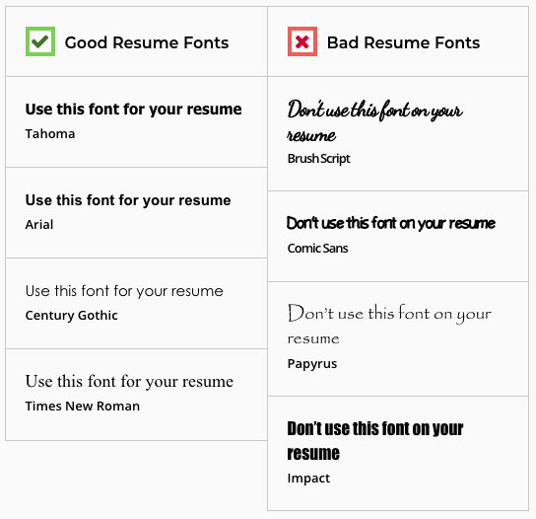

#2—What are Some Good Tips for Writing a Resume?
- Personalize your resume by adding pops of color or selecting an engaging, yet readable font
- Leave out any details that may force an employer, recruiter, or headhunter to throw out your
resume before looking at it such as a headshot, marital status, religious affiliation, political
affiliation, and date of birth or age.
- Avoid including over used words that do not distinguish you from other candidates
applying for the same position such as ‘hard worker’ or ‘team player’.
- Tailor your resume to the job you are applying to and emphasize skills that an employer is
looking for. Don’t include irrelevant work experiences.
- Write your resume in the first person, but don’t use ‘I’ or ‘my’, and in present tense if you are
currently employed. Past work experience should be written in the past tense. Use as many
action words as possible and try to avoid repetition.

#3—Resume Objective/Summary

Think of this as a 30-second “elevator pitch” where you explain what you bring to the table and why a prospective employer should hire you. Ideally, a resume summary should be between 1-2 sentences long and summarize what you have to offer and why an employer should hire you.

